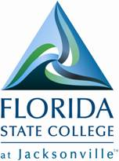
FLORIDA STATE COLLEGE AT JACKSONVILLE
KENT CAMPUS
3939 ROOSEVELT BOULEVARD
JACKSONVILLE FL 32205

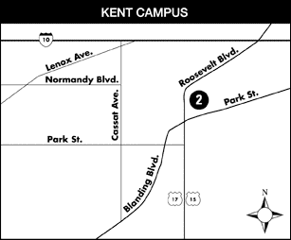

2010 ALPO CONFERENCE will be held at Florida State College Kent Campus
Building E (Park in the lot closest to Plymouth Street; the building with the large “E” will be right in front of you) – see the FSCJ Kent Campus Locator PDF
Upstairs – Room E220

