On the Orbit of Mercury.
This is the first part of a talk given by Roger Venable at the ALPO meeting in Las Cruces, New Mexico, on July 23, 2011.

You have seen in each of the last several Mercury reports in JALPO the following diagram:
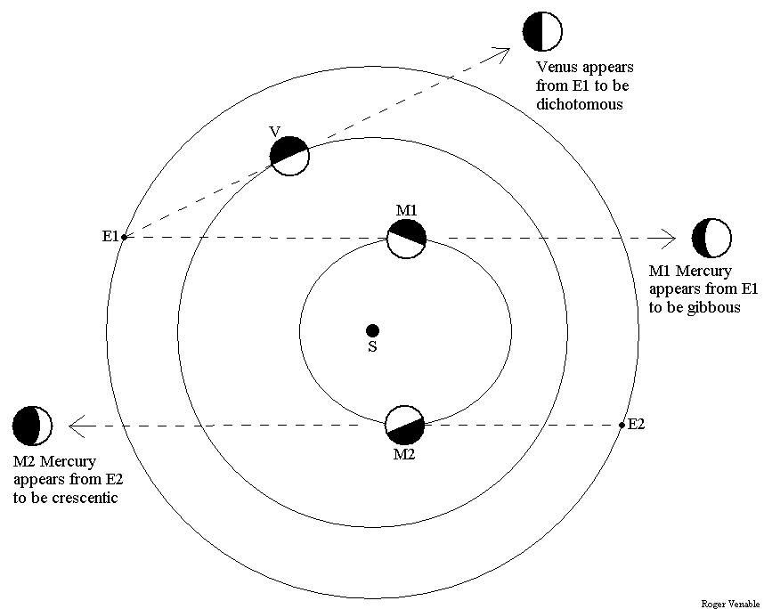
.
Here is the usual caption: Although Venus appears to be near half-phase when at greatest elongation, Mercury often does not. The orbits of Earth, Venus, and Mercury are drawn here, with the Sun ‘S’ at the center. E1 and E2 represent two positions of Earth along its orbit, V represents Venus, and M1 and M2 represent two positions of Mercury in its orbit. An observer at E1 will see Venus at greatest elongation when his line of sight is tangent to the orbit of Venus, as drawn. Since the orbits of Earth and Venus are nearly round, the E1-Venus-Sun angle is close to 90 degrees, and Venus appears at half-phase (“dichotomy”.) In contrast, the observer at E1 who sees Mercury at its greatest elongation at M1, with his line of sight tangent to the orbit of Mercury, sees a gibbous planet because the E1-M1-Sun angle is less than 90 degrees. On the other hand, an observer at E2 who sees Mercury at its greatest elongation at M2 sees a crescentic planet because the E2-M2-Sun angle is greater than 90 degrees. Due to the oval shape of Mercury’s orbit, its phase at greatest elongation can be anywhere from 37 percent to 63 percent. – Editor

When does this occur? Well, the long axis of the orbit of Mercury is oriented so that, at greatest elongations, the times of greatest deviation from dichotomy are in June and December, like this:
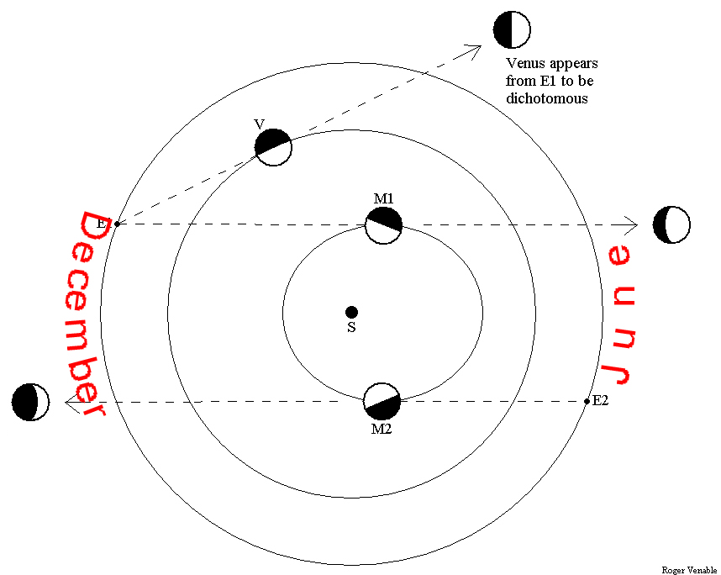
.
At greatest elongation in June, Mercury appears crescentic, while at greatest elongations in December, it appears gibbous. Imagine that it’s the middle of June and you are standing in the Wal-Mart parking lot at noon and looking up at the Sun, high in the south. Imagine that the daytime sky is dark, and that you can see the stars and, wonder of wonders, you can also see the outline of the orbit of Mercury in the sky. Then, imagine superimposed on that view two large pictures of Mercury on it orbit, one picture at it greatest eastern elongation and one picture at its greatest western elongation. Here’s what you are seeing:
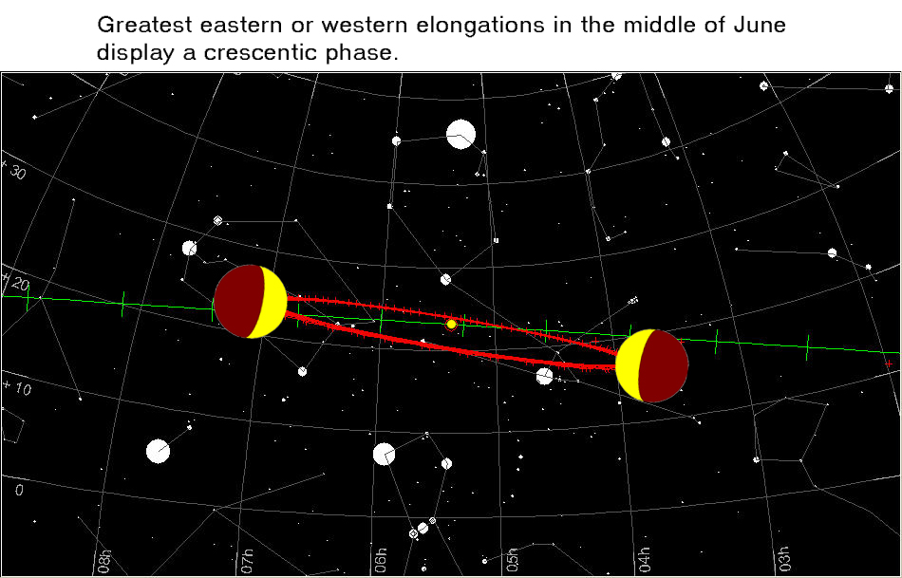
.
In this mental image, north is straight up, your zenith. You see the winter constellations, and the ecliptic is in green. (Is that its real color?) The Sun is on the ecliptic, of course. The orbit of Mercury is red, and the actual path of the planet is the outer edge of the red oval that you see. Notice that the orbit of Mercury is tipped with respect to the ecliptic. It is not only tipped so that the left (east) side of the orbit is more northerly, and the right side is more southerly, but is also tipped so that the near edge of the orbit is slightly below you, and you are looking downward at the northern side of Mercury’s orbit. This causes a perspective effect in which the far side of the orbit appears nearer the Sun in the sky than the near side appears. The images of the planet are crescentic, and this representation is about as crescentic as it would actually be were a greatest elongation to occur in this month.

Now imagine that you repeat this observation (. . . from the Wal-Mart parking lot, of course – where else can you see the sky like this?) in the middle of December. Here’s what you’ll see:
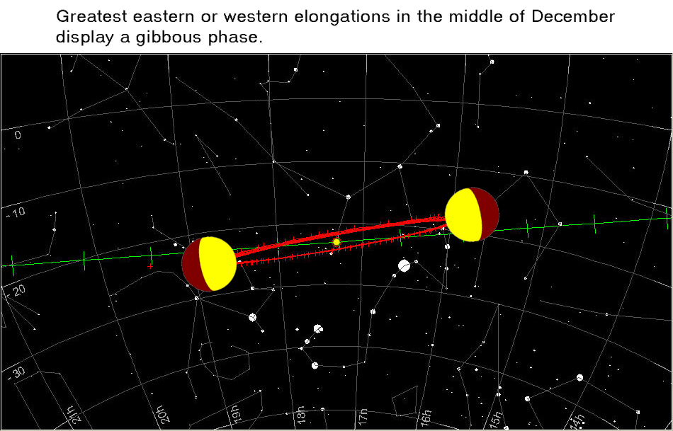
.
Now you are looking at Mercury’s orbit from the other side. It appears to be tipped the opposite direction with regard to the ecliptic. The near edge of the orbit is slightly above you, and you are looking slightly upward at the south side of Mercury’s orbit. The perspective you have on the oval orbit is such that the near side and the far side now appear to be nearly the same distance from the sun. The planet, when seen at greatest elongation in December, appears gibbous, as drawn. There is another perspective effect that is evident when you compare the December diagram with that of June: the red orbit appears wider in June, simply because you are closer to it in June.

It is interesting to watch these perspective effects change as Earth orbits the Sun. The following 12 diagrams are the Wal-Mart view of Mercury’s orbit on the first of each month. In the original talk that I gave in Las Cruces, I flipped rapidly through these so that you could watch the change occur, almost like a movie. You can do this by capturing each diagram from this file, and filing them in the same folder on your computer. Then, open one of them in Windows Picture and Fax Viewer, and use the right arrow key to rapidly advance from one to another.

January 1st:
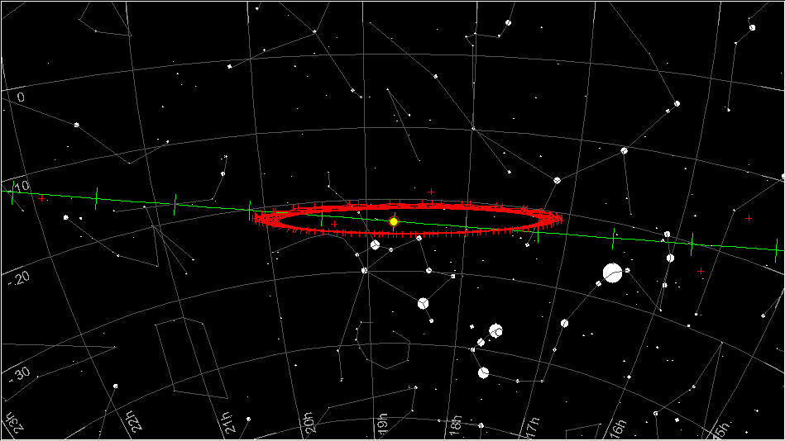
.
February 1st:
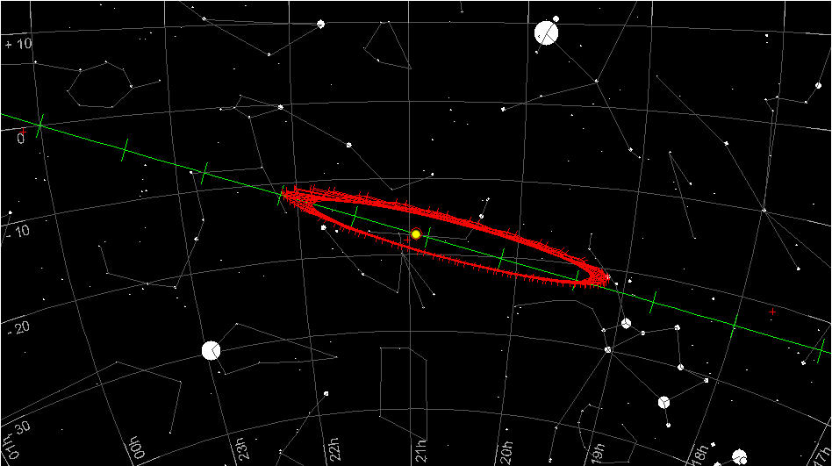
.
March 1st:
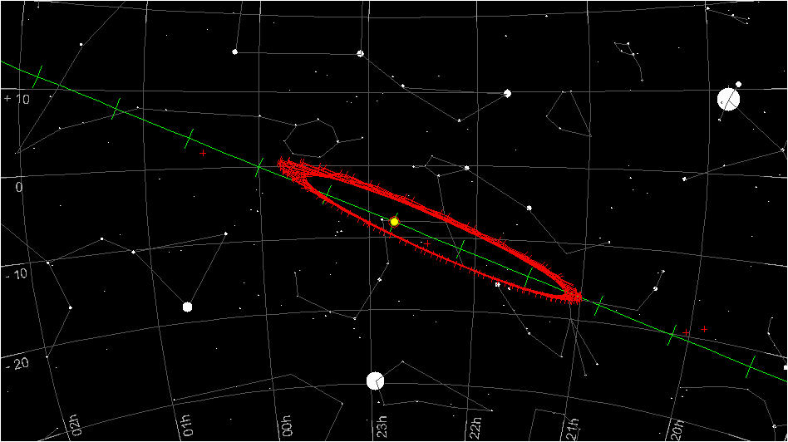
.
April 1st:
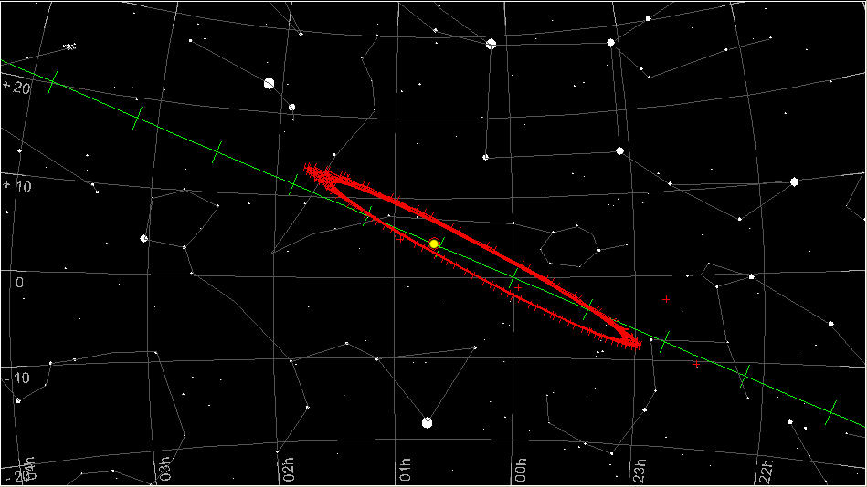
.
May 1st:
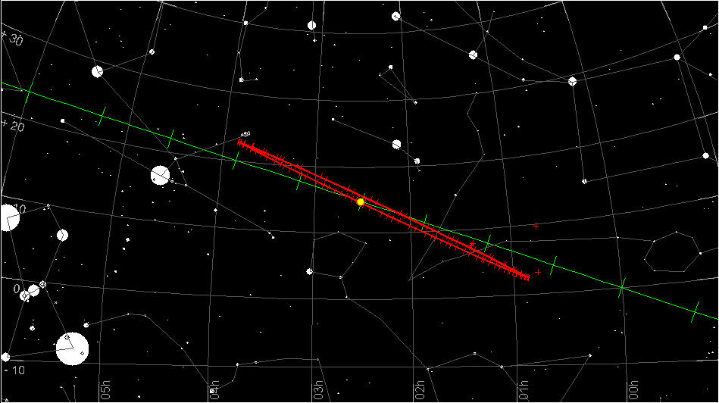
.
June 1st:
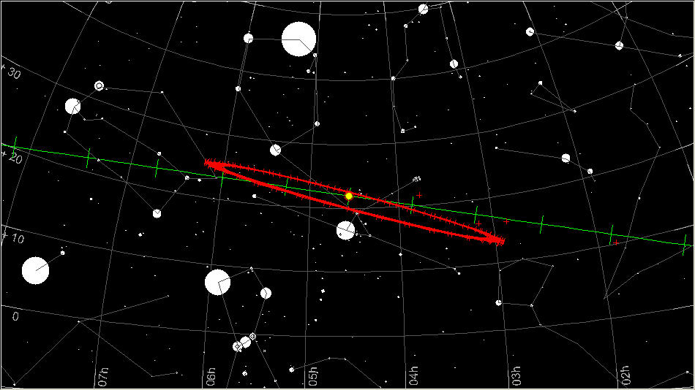
.
July 1st:
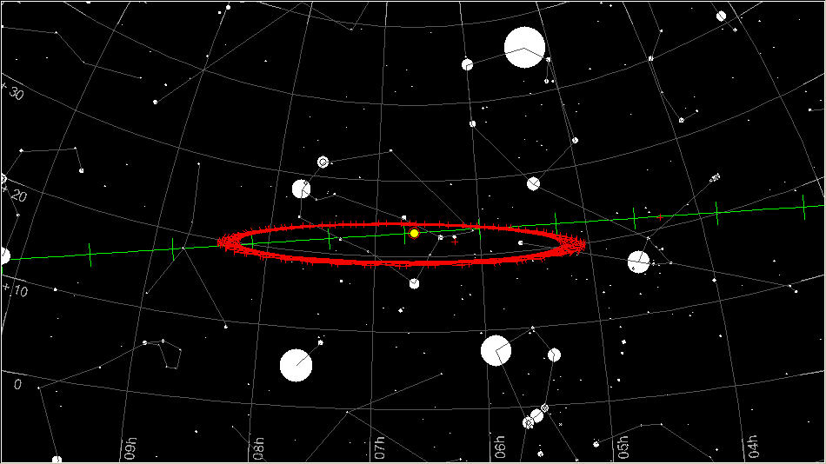
.
August 1st:
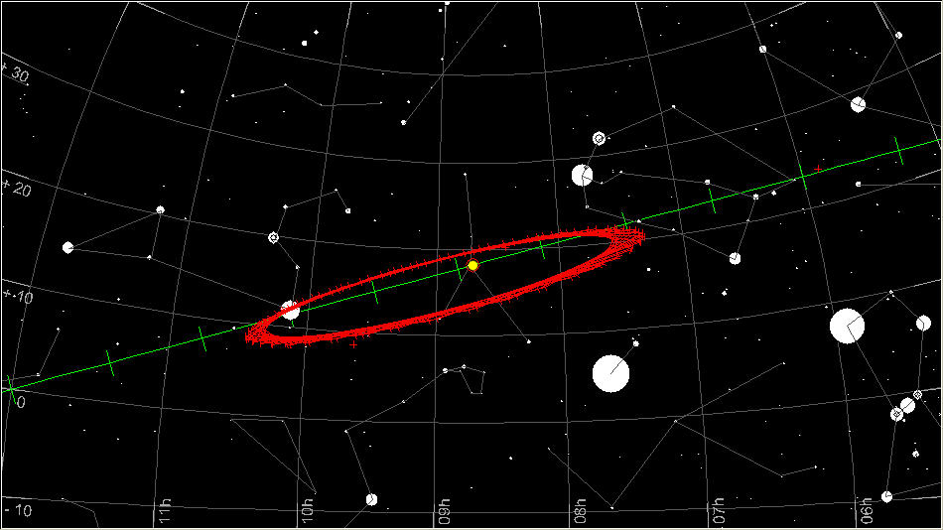
.
September 1st:
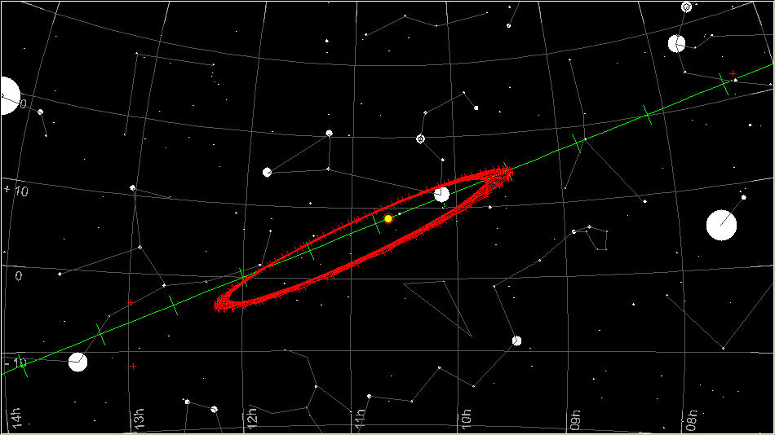
.
October 1st:
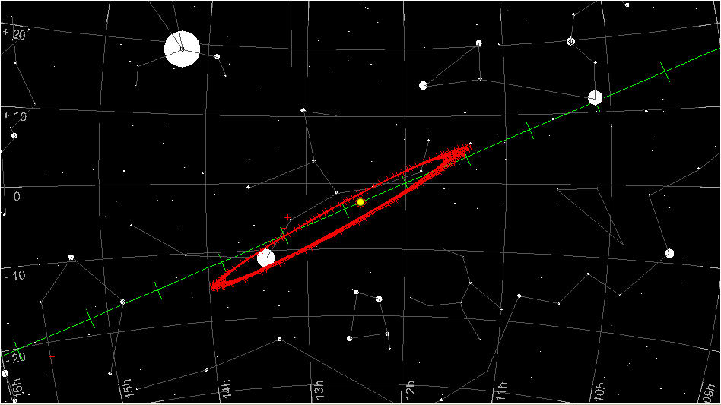
.
November 1st:
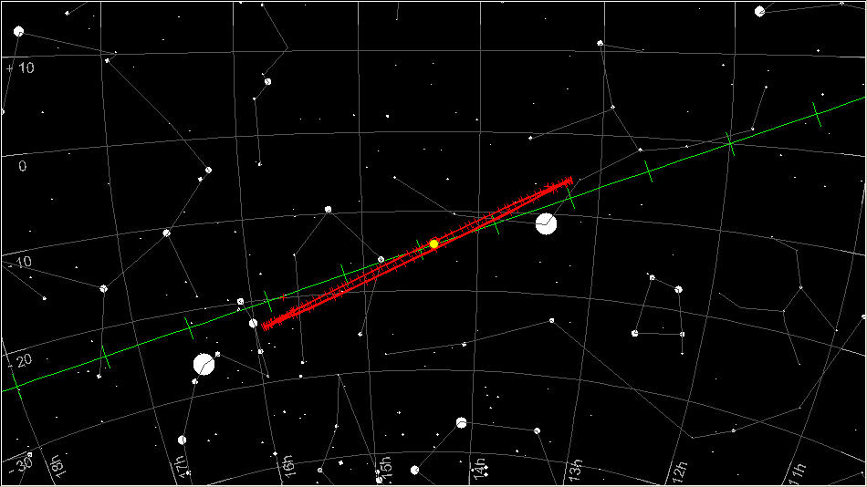
.
December 1st:
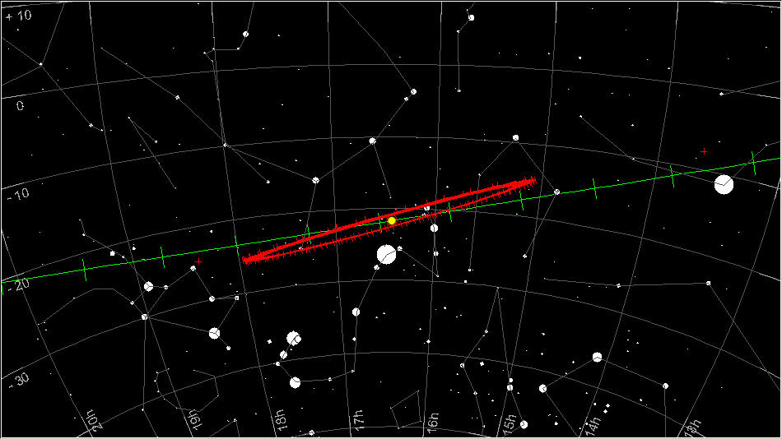
.
As you scroll through these orbit diagrams, notice the three effects: (1) The change in the direction of tilt of the orbit of Mercury with respect to the ecliptic. Notice that the orbit tilts slightly more than the ecliptic does, but not in perfect synchrony with the tilt of the ecliptic – Mercury’s orbit lags by about 7 weeks. (2) The change in the distance of the left and right edges of the orbit from the Sun, so that there is an aphelic side and a perihelic side. (3) The alternation of our gaze from a vantage point above the orbit to one below it, and back again.

You may notice that Mercury’s orbit is edge-on to our line of sight on approximately May 10th and November 10th. At those times, the near side of the orbit crosses the face of the Sun -- those are the seasons of transits of Mercury. You can see that the orbit is tipped about 7 degrees from the ecliptic.

Now let’s consider what time of year we should expect morning and evening elongations to be at their best. Notice that there are four factors related to our perspective on Mercury’s orbit that determine how far above the horizon the planet is at the end of civil twilight: the tilt of the ecliptic, the tilt of the orbit of mercury with respect to the ecliptic, the aphelic side of the orbit being above or below the horizon, and the apparent size of the orbit related to our seasonal distance from it. (By the way, I’m using 32 degrees north and 32 degrees south latitude because I live 32 degrees from the Equator. Notice that the lower the degrees, the higher the temperature.)

For observers in the Northern Hemisphere, the tilt of the ecliptic with respect to the horizon is greatest at sundown on about March 22 – the spring equinox. The tilt of Mercury’s orbit with respect to the ecliptic is favorable in the spring, so that these two factors work together to raise Mercury above the horizon in evening elongations in spring. The time when these two factors work maximally together is about April 1. That is, from the Northern Hemisphere, Mercury will be highest above the horizon in evening twilight if the greatest elongation occurs on about April 1st. On that date, at the end of civil twilight (the Sun is 6 degrees below the horizon at the end of civil twilight) the orbit projects against the sky and horizon like this:
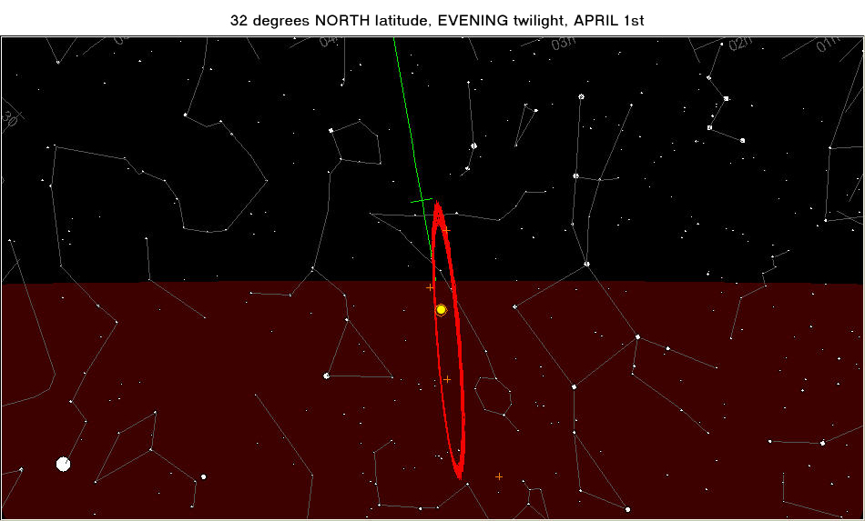
.
With the Sun 6 degrees below the horizon, if Mercury is at greatest elongation it will be 14 degrees above the horizon. This is a favorable condition, a good apparition for northern observers. Notice that, though the tilt of the ecliptic and the orbit are quite favorable, the perihelic wing of the orbit is above the horizon – so Mercury is lower than it would be were the aphelic wing of its orbit projecting above the horizon. The aphelic wing projects above the horizon as seen in spring mornings. Is the morning apparition better in spring? Here it is:
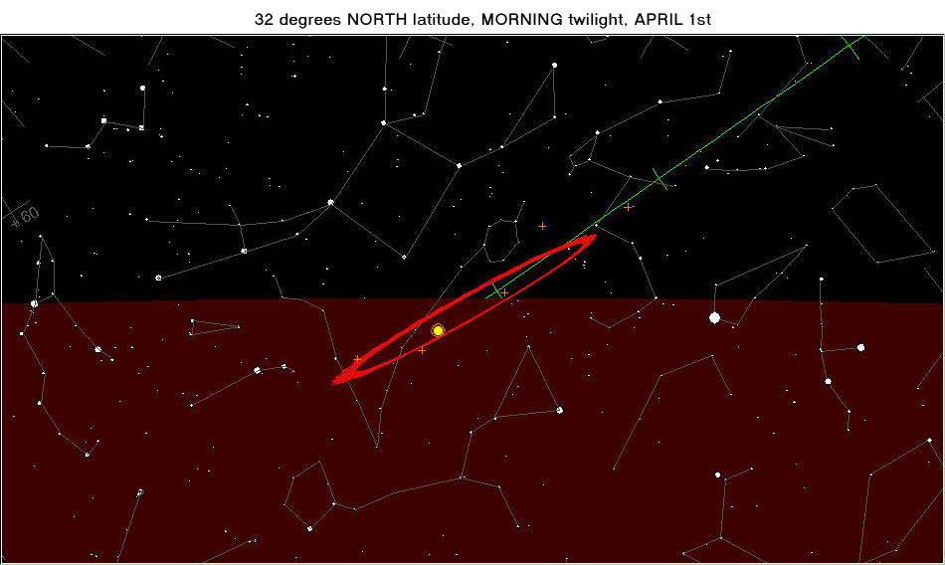
.
Now the aphelic wing is favorably placed but the tilts of the ecliptic and the orbit conspire to make Mercury, at greatest elongation, less high than it is in the evening. It can’t get higher than 10 degrees at the end of civil twilight. So, in the spring, evening apparitions are less favorable than morning apparitions for northern observers.

But we’re missing a few permutations of this. How about evening apparitions is autumn? Here is what they are like:
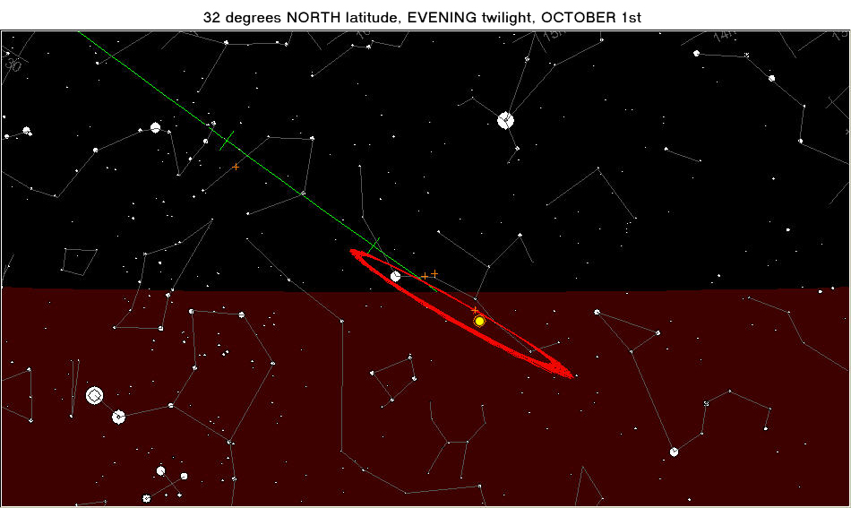
.
Like the morning apparition in spring, this evening apparition in autumn has unfavorable tilts of the ecliptic and the orbit, but a favorable presentation of the aphelic wing of the orbit. At greatest elongation on October 1st in an evening apparition, Mercury can get only 7.5 degrees above the horizon at the end of civil twilight.

However, the morning apparition on October 1st is a good one. It resembles the evening apparition of the spring, with favorable tilts but with presentation of the perihelic wing of the orbit:
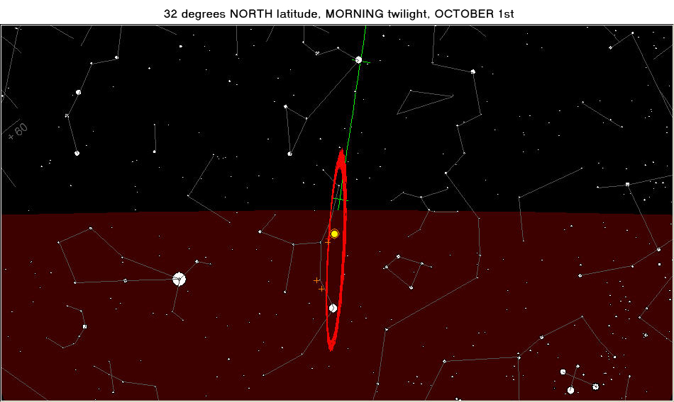
.
In northern morning autumn apparitions, Mercury can get 13.5 degrees above the horizon. This is nearly as good as northern evening apparitions in spring. The slight advantage of the evening spring apparition is due to the oval orbit of Mercury being slightly closer to Earth on April 1 than on October 1.

Notice that, for each of the above situations, when the tilts are favorable, the aphelic-perihelic situation is unfavorable, and vice versa. This is the situation for northern observers.

Now let’s consider the comparable presentations of Mercury for those of us who observe from Earth’s Southern Hemisphere. Although it may be difficult to conceptualize, the horizon is at a different angle in the Southern Hemisphere, which makes the tilts favorable for southern observers when they are unfavorable for northern observers. However, the presentation of the aphelic wing is the same, whether an observer is in the Northern or the Southern Hemisphere. This results in the following situation for a spring, morning apparition, as seen from 32 degrees south latitude:
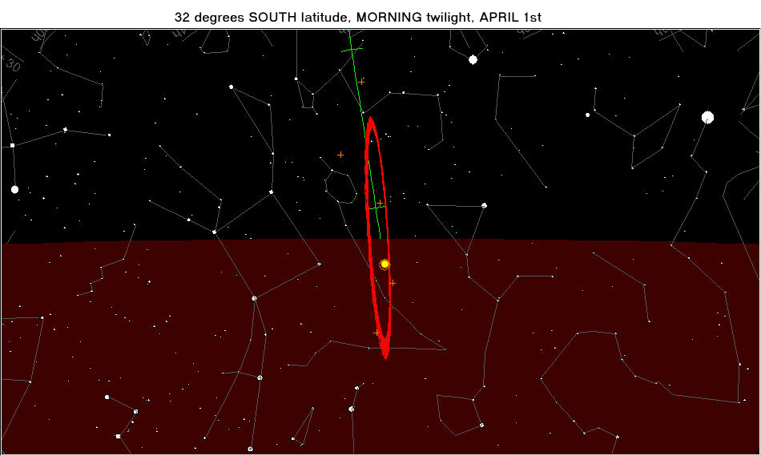
.
The tilt of the ecliptic and the orbit are both favorable, and the aphelic wing of the orbit is favorably placed, so that at greatest elongation on April 1st the planet will be 24 degrees above the morning horizon, at the end of civil twilight! A similar situation holds for autumn evenings:
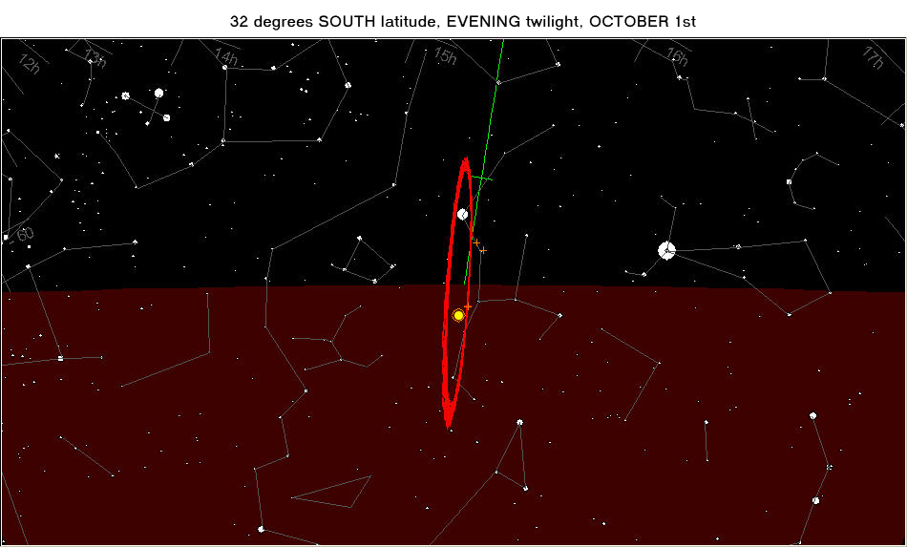
.
Here, again, the tilts and the aphelic wing are favorably placed, so that the planet can be 21 degrees above the horizon when at greatest elongation. Note that the orbit appears slightly smaller in diameter in autumn, as compared to spring, so the elevation of the planet is slightly less.

Northern Hemisphere observers never have it so good. However, with the blessing comes a curse. Since the tilts and the aphelic wing change together as seen from the Southern Hemisphere, when they are unfavorable, they are all unfavorable together. Here is the situation for southerners at evening apparitions in the spring:
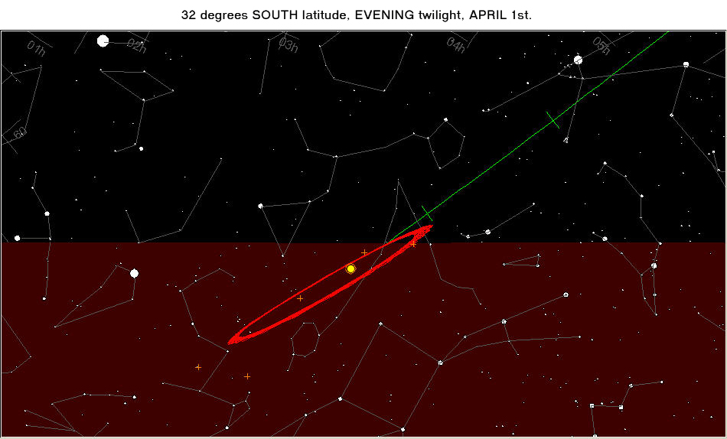
.
This is a really bad apparition, with all factors unfavorable, so that Mercury at greatest elongation can only get 3.5 degrees above the horizon at the end of nautical twilight! Similarly, southern mornings in autumn may bring a very unfavorable apparition:
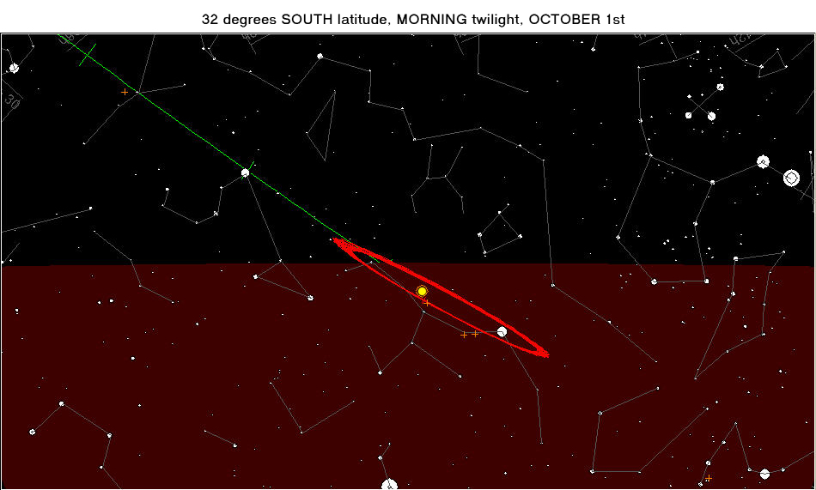
.
It’s only 4 degrees up. Northerners never have it so bad.

Be that as it may, the most important thing to know it this:
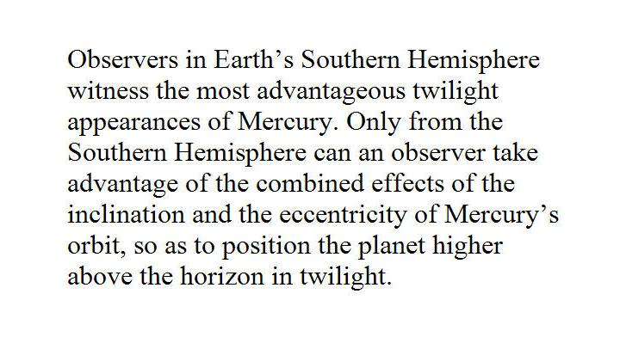
.
When I first looked into this stuff, I thought maybe that the orientation of the orbit of Mercury was transient. Since I was a child, I have read about how this orbit was used to support the General Theory of Relativity. The orbit is precessing as Einstein’ theory predicts. Just how transient is it?
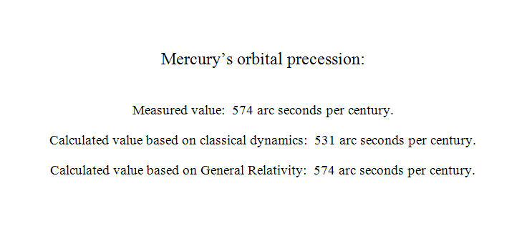
That’s slow.
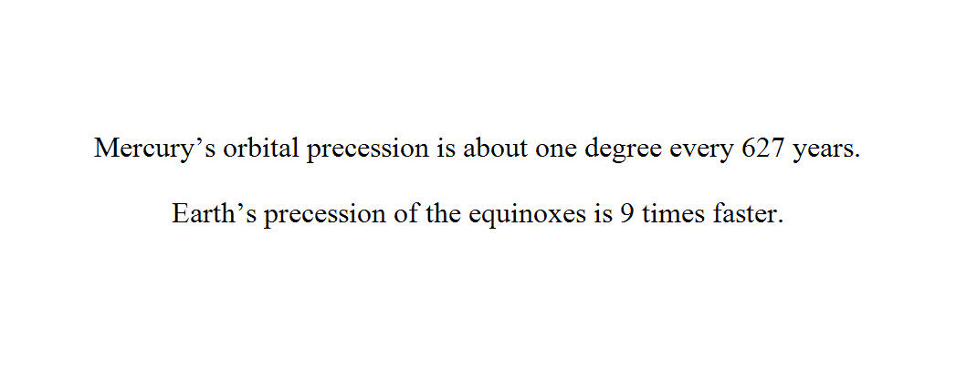
So, the orientation of Mercury’s orbit will not change appeciably during our lifetimes.

“That completes Part One of the massacree” (a quote from Arlo Guthrie)

Roger Venable
Coordinator, ALPO Mars Section
Assistant Editor OSLT, JALPO

Abbreviations: ALPO is Association of Lunar and Planetary Observers.
JALPO is Journal of the Association of Lunar and Planetary Observers.
OSLT is Or Something Like That

